
2010 JC2 H1 Prelim Paper 1 Suggested Solution

1 | A sample of 0.020 mol of an oxochloride of sulfur, SO₂Cl₂, reacted completely with 250 cm³ of water according to the following equation.  SO₂Cl₂ (l) + 2 H₂O (l) → H₂SO₄ (aq) + 2 HCl (aq)  What would be the volume of 0.1 mol dm⁻³ aqueous sodium hydroxide required to neutralise 10.0 cm³ of the above resulting solution?
 | A | 16.0 cm³
 | B | 32.0 cm³
 | C | 48.0 cm³
 | D | 64.0 cm³

Solution: B
2 NaOH + H₂SO₄ → Na₂SO₄ + 2 H₂O
Amt of H₂SO₄ in 10.0 cm³ of solution= 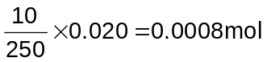
Amt of NaOH required= 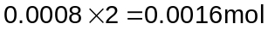

NaOH + HCl → NaCl + H₂O
Amt of HCl in 10.0 cm³ of solution= 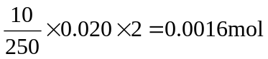
Amt of NaOH required = 0.0016mol
Total Volume of NaOH required = 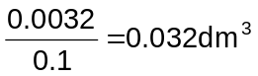

2 | Basic hydrolysis of acetonitrile, CH₃CN, takes place according to the following equation:  CH₃CN + NaOH + H₂O → CH₃COO⁻Na⁺ + NH₃  A sample of acetonitrile was boiled with aqueous NaOH and the NH₃ gas evolved was passed into 50 cm³ of 1.00 mol dm⁻³ of HCl. The excess acid required 26.00 cm³ of 1.00 mol dm⁻³ NaOH solution for neutralisation. What was the mass of acetonitrile used?  (Given M_{r} of CH₃CN = 41.0)
 | A | 0.492 g
 | B | 0.984 g
 | C | 1.07 g
 | D | 1.97 g

Solution: B
Eqn 1: NH₃ + HCl → NH₄Cl
Eqn 2: NaOH + HCl → NaCl + H₂O

From eqn 2:
Amt of NaOH required = 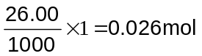
Amt of HCl in excess = 0.026mol
Initial amt of HCl = 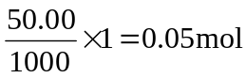
Amt of HCl reacted = 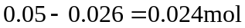

From Eqn 1:
Amt of HCl reacted = Amt of NH₃ = Amt of CH₃CN = 0.024mol

Mass of CH₃CN= 0.024 x 41 = 0.984 g

3 | In a redox experiment, 15.0 cm³ of 0.2 mol dm⁻³ of acidified manganate(VII) ions was used to oxidise 25.0 cm³ of 0.6 mol dm⁻³ of an aqueous solution of A^{n+}.  What is the change in oxidation number for element A?
 | A | –1
 | B | –2
 | C | +1
 | D | +5

Solution: C
[R]: MnO₄⁻ + 8H⁺ + 5e → Mn²⁺ + 4H₂O ---- (1)
[O]: A^{n+} → A(^{n+x)} + xe -------(2)

Amt of MnO₄⁻ = 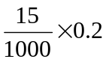 = 0.003 mol
Amt of oxide of A = 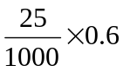 = 0.015 mol

MnO₄⁻ ≡ 5 A^{n+}

Hence,
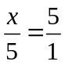
x = 1

Since A lost one electron, change in oxidation state = +1

4 | Beams of particles travelling at the same speed from different sources are subjected to an electric field as shown in the diagram below. The path for a beam of neutrons has already been drawn.  source  +  -  neutrons  C  B  D  Which of the following correctly represents the particles labelled B, C and D?
 |  | B | C | D
 | A | ⁴He⁺ | ¹H⁺ | electrons
 | B | ⁴He⁺ | ²H⁺ | ¹H⁺
 | C | ¹H⁺ | ²H⁺ | ³H⁺
 | D | ¹H⁺ | ²H⁺ | electrons

Solution: D
Positively charged ²H⁺ and ¹H⁺ will be deflected towards the negative terminal and electron (negatively charged) will be deflected towards the positive terminal.

Since angle of deflection is proportional to (e /m) values,
e/m (¹H⁺) = 1/1 = 1
e/m (²H⁺) = 1/2 = 0.5

¹H⁺ is lighter hence angle of deflection would be 2 times greater than ²H⁺.

5 | Which diagram represents the arrangement of electrons in the 3rd and 4th quantum shell of a Co²⁺ ion?
 | A | __ __ __ __ __ __ __ __ __ __  3s 3p 3d 4s
 | B | __ __ __ __ __ __ __ __ __ __  3s 3p 3d 4s
 | C | __ __ __ __ __ __ __ __ __ __  3s 3p 3d 4s
 | D | __ __ __ __ __ __ __ __ __ __  3s 3p 3d 4s

Solution: C

Co: 1s² 2s² 2p⁶ 3s² 3p⁶ 3d⁷ 4s²
Co²⁺: 1s² 2s² 2p⁶ 3s² 3p⁶ 3d⁷

6 | Which one of the following statements best explains why the boiling point of butanone (79.6 ºC) is higher than that of pentane (36.1 ºC)?
 | A | The relative molecular mass of butanone is higher than that of pentane.
 | B | The butanone molecule has a larger surface area than the pentane molecule.
 | C | The covalent bonds in butanone molecules are stronger than those in the pentane molecules.
 | D | There are stronger dipole interactions between butanone molecules but only weak interactions between pentane molecules.
Solution: D
The M_{r} of butanone and pentane are both 72. Permanent dipole-dipole interaction exist between the butanone due to the presence of polar C=O bond. Pentane only has weak temporary induced dipole interactions.

7 | The decomposition of hydrogen peroxide was found to be a first order reaction. Which of the following graphs is correct?  A B  Rate of decomposition of H₂O₂  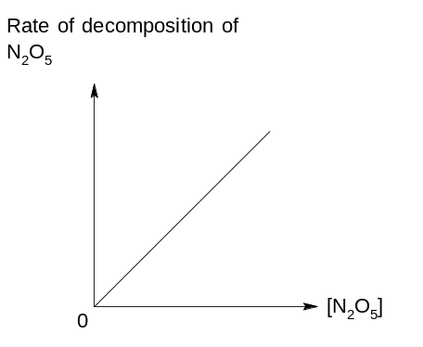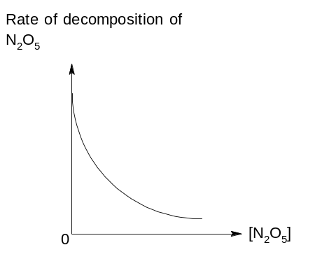  Rate of decomposition of H₂O₂  [H₂O₂]  [H₂O₂]  [H₂O₂]  [H₂O₂]  C D  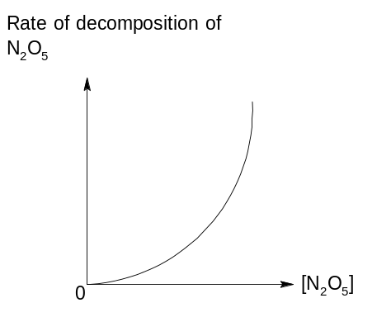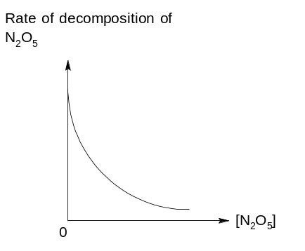  [H₂O₂]  [H₂O₂]  time  time  time
Solution: A
8 | The graph below shows how the percentage of gaseous products present at equilibrium varies with temperature and pressure.  % products at equilibrium  T ºC  (T + 10) ºC  pressure  Which of the following equilibrium correctly represents the graph above?
 | A | H₂ (g) + I₂ (g) 2HI (g) ∆H = + 53 kJ mol⁻¹
 | B | N₂O₄ (g) 2 NO₂ (g) ∆H = + 57 kJ mol⁻¹
 | C | N₂ (g) + 3 H₂ (g) 2 NH₃ (g) ∆H = - 92 kJ mol⁻¹
 | D | 4 NH₃ (g) + 5 O₂ (g) 4 NO (g) + 6 H₂O (g) ∆H = - 950 kJ mol⁻¹

Solution: C
When pressure is increased at constant temperature,
By Le Chatelier’s Principle, the position of equilibrium shifts to the right to decrease total amount of gases.
When temperature is increased at constant pressure,
By Le Chatelier’s Principle, the position of equilibrium shifts to the left to absorb heat, favouring the backward endothermic reaction.

9 | The graph below shows the change in concentrations of the equilibrium mixture with time for the following reaction:  F (g) + 2 G (g) H (g)  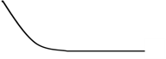  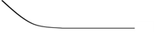  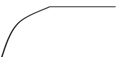  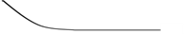  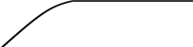  Concentration /mol dm⁻³  F  G  H  T₁  T₂  time  Which of the following shows the correct conditions applied to cause the change at time T₁ and T₂?
 |  | T₁ T₂
 | A | decrease in volume increase in [H]
 | B | decrease in volume decrease in [H]
 | C | increase in volume increase in [H]
 | D | increase in volume decrease in [H]

Solution: A
At T₁, [F], [G] and [H] increased at the same time and it is due to the decrease in volume which increases the pressure of the system.

At T₂, [F] and [G] increased while [H] decreased implied that the backward reaction has been favoured and hence there must have been an increase in [H].

10 | The following graph shows the pH changes when 0.15 mol dm⁻³ of Ba(OH)₂ is added to 20 cm³ of 0.15 mol dm⁻³ of ethanoic acid.  13  pH  L  K  J  3  Volume of Ba(OH)₂ / cm³  Which of the following statements is true about this titration?
 | A | The equivalence volume for this titration is 20 cm³.
 | B | A buffer region is observed at point J.
 | C | A good indicator that can be used in this titration is universal indicator.
D pH at point K is smaller than 7.
Solution: B
Acidic buffer is found before the equivalence point in a strong base weak acid titration as there is excess acid and salt present.
11 | 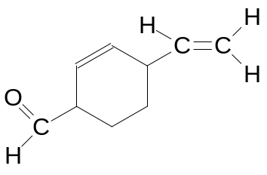  Compound M  Compound M was reacted with hydrogen gas in the presence of palladium catalyst. What is the total number of sigma and pi bonds found in the product formed?  No. of sigma bonds No. of pi bonds
 | A | 21 3
 | B | 25 2
 | C | 26 1
 | D | 28 0

Solution: D
Both C=C and aldehyde group in compound M will be reduced.
The product is 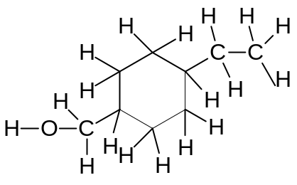which consist of 28 sigma and 0 pi bond.
12 | 3-methylpentane was reacted with chlorine gas in the presence of ultraviolet light. What is the total number of possible isomers formed, assuming mono-substitution took place?
 | A | 4
 | B | 5
 | C | 6
 | D | 14

Solution: A

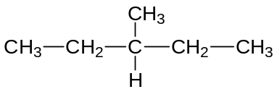3-methylpentane
4 possible products are formed:
1-chloro-3-methylpentane; 2-chloro-3-methylpentane; 3-chloro-3-methylpentane; 3(chloromethyl)pentane

13 | Which of the following shows the correct products formed when buta-1,3-diene undergoes Reaction 1 and Reaction 2 separately?  Reaction 1: With excess cold alkaline KMnO₄ followed by heating.  Reaction 2: With hot acidified KMnO₄.
 |  | Reaction 1 | Reaction 2
 | A | 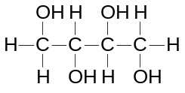 | CO₂ and H₂O
 | B | CO₂ and H₂O | 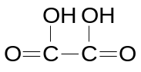
 | C | CO₂ and H₂O | CO₂ and H₂O
 | D | 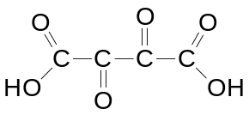

Solution: C
Mild [O] 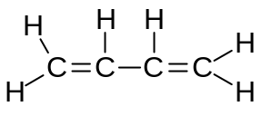
Cold alkaline MnO₄⁻ strong [O]
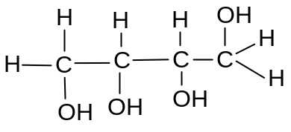 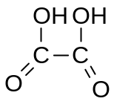 + CO₂ + H₂O
heat
strong [O]
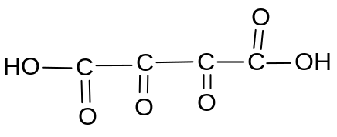 CO₂ + H₂O
14 | Which of the following is the major product formed when CH₃CH=C(NO₂)CH₂CH=C(CH₃)₂ reacts with HBr?
 | A | 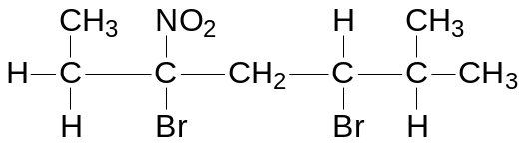
 | B | 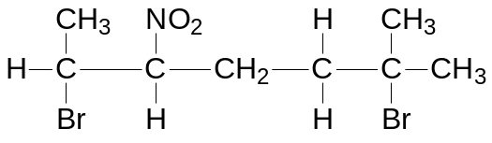
 | C | 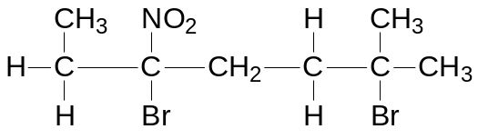
 | D | 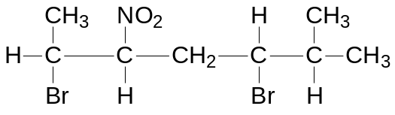

Solution: C

15 | Which one of the following will be formed when butane-1,3-diol is distilled with hot acidified potassium dichromate(VI)?
 | A | CH₃COCH₂CHO
 | B | CH₃COCH₂COOH
 | C | CO₂ and H₂O
 | D | CH₃CH(OH)CH₂COOH

Solution: A

2º alcohol will be oxidised to a ketone while 1º alcohol will be oxidised to an aldehyde.

16 | 1 mol of organic compound N undergoes elimination with ethanolic sodium hydroxide to form 2 mol of HBr.  What could compound N be?
  A  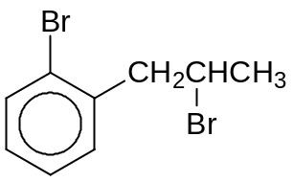 | B  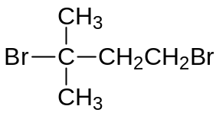
  C  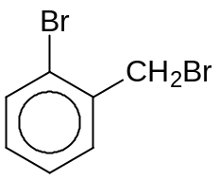 | D  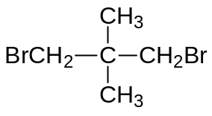
Solution: B
Halogenoarene does not undergo elimination.
The 2 Br in option D do not undergo elimination because there is a lack of H on the neighbouring carbon.

17 | Experiments are carried out on three compounds R, S and T.  A sample of 0.01 mol of each compound is heated under reflux with 50 cm³ of 1.0 mol dm⁻³ aqueous NaOH (in excess) until hydrolysis is completed and any ammonia produced is expelled from solution. The excess NaOH is found to require 20 cm³, 30 cm³ and 40 cm³ of 1.0 mol dm⁻³ HCl for neutralization.  Which sequence of compounds matches the above results?
  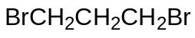 | 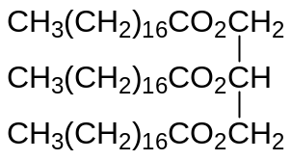 | 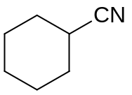
  R | S | T
 |  | 20 cm³ of HCl required | 30 cm³ of HCl required | 40 cm³ of HCl required
 | A | R | S | T
 | B | R | T | S
 | C | S | R | T
 | D | T | S | R
Solution: C

Volume of HCl used = Volume of excess OH⁻
Volume of OH⁻ reacted with R: S: T = 20:30:10
Volume of excess OH⁻ that reacted with HCl (R, S, T) = (50-20): (50-30) : (50-10) = 30: 20 : 40

18 | Which reagent gives the same visible observation with propanoic acid and propanal?
 | A | Dilute aqueous sodium carbonate
 | B | Alkaline aqueous iodine
 | C | Sodium metal
 | D | Tollen’s reagent

Solution: B
Both do not undergo oxidation with alkaline aqueous iodine, hence brown iodine remains in both cases.

19 | Terephthalaldehyde is used as an intermediate for manufacturing of dyes and fluorescent whitening agents. It can be synthesized from 4-methylbenzoic acid via a 3-step synthesis.  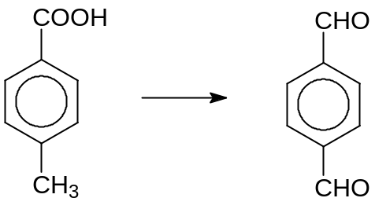  3 steps  4-methylbenzoic acid Terephthalaldehyde  Which of the following reagents and conditions are needed for the conversion?
 |  | Step1 | Step2 | Step3
 | A | Cr₂O₇²⁻ / H⁺, heat to distill | LiAlH₄, r.t.p | Hot KMnO₄ / H⁺
 | B | Cr₂O₇²⁻ / H⁺, heat to distill | NaBH₄, r.t.p | Hot KMnO₄ / H⁺
 | C | Hot KMnO₄ / H⁺ | LiAlH₄, r.t.p | Cr₂O₇²⁻ / H⁺, heat to distill
 | D | Hot KMnO₄ / H⁺ | NaBH₄, r.t.p | Cr₂O₇²⁻ / H⁺, heat to distill

Solution: C

Methyl side chain can only be oxidised using KMnO₄ (a stronger oxidising agent than Cr₂O₇²⁻) while acids can only be reduced using LiAlH₄ (a stronger reducing agent than NaBH₄).

20 | A compound V gives compound W, C₈H₈O, on oxidation under appropriate conditions. W gives a precipitate on warming with Fehling’s reagent.  Which of the following could be V?
 | A | 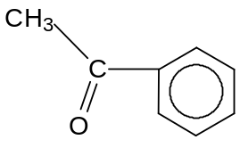
 | B | 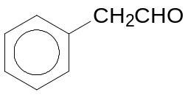
 | C | 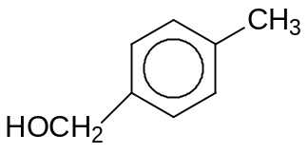
 | D | 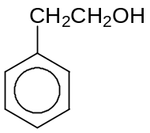

Solution: D
- A cannot be oxidized further.
- B doesn’t form C₈H₈O upon oxidation.
- C undergoes oxidation to form 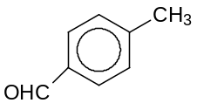or 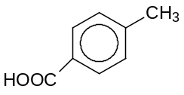which does not gives ppt with Fehling’s.
- D undergoes oxidation to form 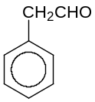which is an aliphatic aldehyde (gives ppt with Fehling’s).

21 | The structure of an organic compound X is shown below:  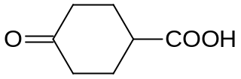  Compound X  Which one of the following statements is true?
 | A | The six-membered carbon ring in X is planar.
 | B | X reacts with cold HCN under basic conditions.
 | C | X does not give an orange precipitate with 2,4-dinitrophenylhydrazine.
 | D | Reaction of sodium carbonate with X produces a gas which turns aqueous red litmus blue.

Solution: B
- The six-membered ring is planar about the carbonyl carbon and tetrahedral about the rest of the carbon atoms.
- X gives an orange ppt with 2,4-DNPH as it contains carbonyl functional group.
- X (contains acid functional group) reacts with Na₂CO₃ to produce CO₂ which is an acidic gas. It will turn aqueous blue litmus red.

22 | Which of the following statement is true when the compound below reacts with hot aqueous NaOH?  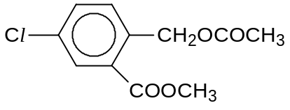
 | A | White fumes are observed.
 | B | A white precipitate is observed.
 | C | Neutralisation has taken place.
 | D | The isolated final product has a low melting point.

Solution: C
Final product:
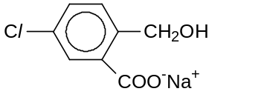

- Product is an ionic salt which has high melting point.
- Basic hydrolysis of esters followed by neutralisation of the carboxylic acid group has occurred.
- There are no white fumes and ppt formed.

23 | A food chemist wants to create the odour of green apples for a product. An ester with this odour has the formula C₂H₅CO₂CH(CH₃)₂. In which of the following will the substances react together to produce this ester?
 | A | C₂H₅OH and (CH₃)₂CHCOOH
 | B | CH₃COOH and CH₃CH(OH)CH₂CH₃
 | C | C₂H₅COOH and C₂H₅CH₂OH
 | D | C₂H₅COOH and (CH₃)₂CHOH

Solution: D

24 | An unknown element forms a chloride which is able to give an acidic solution and an oxide which can dissolve readily in an acidic solution.  What could this element be?
 | A | Calcium
 | B | Aluminium
 | C | Silicon
 | D | Phosphorus

Solution: B
Students must be able to find an element which can give acidic properties for both chloride and oxide. Only aluminium possesses such amphoteric characteristic.

25 | Use of the Data Booklet is relevant to this question.  The graph below shows the second ionisation energies of elements 1 to 4.  The elements are adjacent to each other in the Periodic Table.  Second ionisation energy (arbitrary units)  Atomic number  1  2  3  4  Which statement about the elements 1 to 4 is correct?
 | A | The melting point of the elements increases in the order of 1 > 2 > 3 > 4
 | B | The atomic radius of the elements decreases in the order of 2 < 3 < 4 < 1
 | C | The electrical conductivity of the elements increases in the order 1 < 2 < 3 < 4
 | D | The third ionisation energy of the elements decreases in the order of 3 < 2 < 1 < 4

Solution: C
The atomic number increases from Group VIII, I, II and III.

A | B | C | D
1, 2 and 3  are correct | 1 and 2 only  are correct | 2 and 3 only  are correct | 1 only  is correct

26 | Which of the following contain(s) hydrogen bonds?
 | 1 | NH₄Cl (s)
 | 2 | NH₃ (l)
 | 3 | HNO₃ (l)

Solution: C
Option 1: The N in NH₄⁺ does not contain lone pair of electrons for H-bonding.
Option 2: 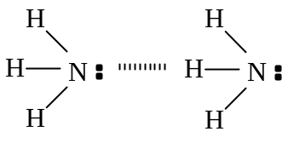
Option 3: 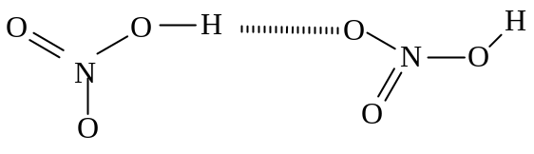

27 | The kinetics of the reaction between compounds Y and Z were shown in the graph below:  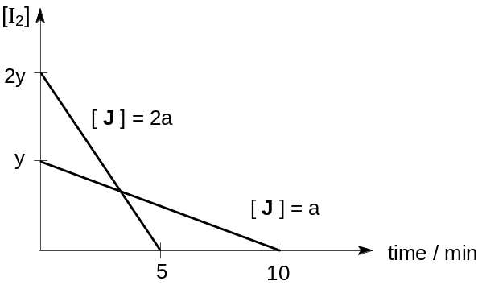  [Y]  [Z] = 2 x  [H] = 2x  [Z] = x  Which of the following conclusion(s) can be drawn from the graph?
 | 1 | The reaction is first order with respect to compound Y.
 | 2 | The reaction is second order with respect to compound Z.
 | 3 | The overall order of reaction is 2.

Solution: C
The reaction is second order with respect to compound Z because rate of reaction increases four times when its concentration is doubled. The reaction is independent of compound Y because a straight line graph was obtained. i.e. rate is independent of [Y] Therefore the overall order of reaction is 2.

28 | In an acid-base titration, 25.0 cm³ of 0.150 mol dm⁻³ HCl was titrated with 0.150 mol dm⁻³ NH₃. The table below shows the data of four acid-base indicators.  Which of the following correctly represent(s) the appropriate indicator(s) used in the above titration?
  Indicator | Approximate pH range
  Congo red | 3.0 – 5.0
  Bromocresol green | 3.8 – 5.5
  Cresol red | 7.2 – 8.8
 | 1 | Congo red
 | 2 | Bromocresol green
 | 3 | Cresol red

Solution: B
For a strong acid-weak base titration, region of rapid pH change lies between pH 3-7.
Only congo red and bromocresol green pH transition range lies within the region of rapid pH change.

29 | The structure of compound B is shown below:  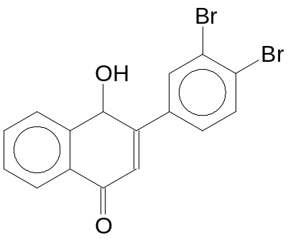  Compound B  What types of reaction will compound B undergo?
 | 1 | Electrophilic substitution and condensation
 | 2 | Nucleophilic substitution and elimination
 | 3 | Neutralisation and nucleophilic addition

Solution: D

Statement 1 is correct:
- presence of benzene ring thus electrophilic substitution can occur.
- Presence of ketone functional group thus condensation reaction is possible with 2,4-DNPH.

Statement 2 is wrong:
- Halogenoarenes cannot undergo nucleophilic substitution and elimination.
- The alcohol has no neighbouring H atoms.Thus elimination is not possible.

Statement 3 is wrong:
- There are no acidic groups present.
- Ketones can undergo nucleophilic addition with HCN.

30 | Compound C can be formed from ethanal in three steps:  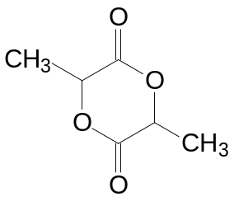  CH₃CHO  Ethanal  3 steps  Compound C  Which of the following reagent(s) and condition(s) is / are required?
 | 1 | Dilute H₂SO₄, reflux
 | 2 | Excess concentrated H₂SO₄, reflux
 | 3 | HCN in aqueous NaOH, cold

Solution: A

CH₃CHO → CH₃CH(OH)CN → CH₃CH(OH)COOH →

-END -

